Henryk Berlewi (1894 Warsaw – 1967 Paris)
The Polish painter, graphic designer and art critic Henryk Berlewi was one of the outstanding figures of POLISH CONSTRUCTIVISM and the YIDDISH AVANT-GARDE. As a theoretician and innovator of functional typography he became a precursor of Op Art and Minimal Art.

Career
Berlewi began his artistic education at the Warsaw School of Fine Arts in 1904 and continued it at the Academy of Fine Arts in Antwerp (1909-10), the Ècole des Beaux Arts and the École des Arts Décoratifs in Paris (1911-12). In 1913 he attended the Warsaw School of Design and in 1918-22 he collaborated with the Warsaw circles of the Futuro-Dadaists and the Yiddish avant-garde. As a co-organiser of exhibitions and theatre performances, a designer of posters, books and artistic magazines, he became an outstanding figure of the so-called Jewish expressionism.

In 1921, at the Warsaw settlement of the Kultur-Lige, Berlewi met El Lissitzky, who stimulated his involvement in international abstract art. His interest in SUPREMATISM and Constructivism intensified in 1922-23 in Berlin, where he was in close contact with Theo van Doesburg, Viking Eggeling, László Moholy-Nagy, Hans Richter and Mies van der Rohe. Berlewi joined the Novembergruppe and participated in the Great Berlin Art Exhibitions in 1922 and 1923 and the 1922 Congress of the International Union of Progressive Artists in Düsseldorf, where he met Stanisław Kubicki and Jankiel Adler.
In 1923 he returned to Warsaw and began to help integrating Polish and Jewish artistic circles. In 1924 he became a member of the Blok group but, competing with its co-founders, he organised his own individual exhibition a day before it’s first collaborative show. His manifesto of Mechano-Facture was published in Warsaw in May 1924 and appeared in Herwarth Walden’s Der Sturm journal in September along with a display of his works devoted to this concept.

Mechano-Facture promoted pictorial two-dimensionality; it meant to use mechanical means in order to create texture and reject the illusion of three-dimensional space. The reduction of colours to black, white and red, and visual equivalents to geometrical shapes such as circles, squares and raster factures aimed at creating rhythmical arrangements, reflecting the spirit of modernity. Berlewi also applied his theory to commercial art, using it in the product design of this advertising agency Mechano-Reklama (Mechano Advertising), which he had founded together with Aleksander Wat.

In 1927 Berlewi settled in Paris; he travelled through Belgium in 1928-1938, producing portraits of political leaders and literary representatives and pictures of nudes with strong contours defining visual forms. In 1942 he found refuge in Nice and participated in the activities of the French resistance in 1943-44. In 1947 he turned to the ‘reintroduction of the object’ and began painting still lifes inspired by the masters of the 17th century.

Legacy
The Berlewi exhibitions at the Denise René and Creuse galleries in Paris in 1957 initiated the reception of the work of this pioneer of abstract art in Poland and his mechano-facture experiments. They were followed by numerous exhibitions in Paris, Warsaw, Zurich (1950-67) and various places in Germany and Poland (1961-67), among others the shows Der Sturm in Berlin (1961) and Responsive Eye in New York (1965). In consequence, Berlewi, who was also a founder of the Archives de l’Art Abstrait de L’ Avant-Garde Internationale (1960) and a member of the Syndicate de la Presse Artistique Francaişe and the Association Internationale des Critiques d’Art, further strengthened his position in the art scene of the 1960s and his reputation as a precursor of abstract and kinetic art.

References and further readings:

Magdalena Frankowska/Artur Frankowski, Berlewi, Gdańsk: Terytoria, 2009.

Eckhard Neumann, Henryk Berlewi and Mechano-faktura, Typographica 9 (June 1964): 21-28.

Nadine Nieszawer, Marie Boyé, Paul Fogel, Peintres Juifs à Paris 1905-1939 Ecole de Paris, Paris: Editons Denoel, 2000.

Andrzej K. Olszewski, Henryk Berlewi, Warszawa: Wydawnictwo Artystyczno-Graficzne, 1968.

Piotr Rudziński, Awangardowa twórczość Henryka Berlewiego, Biuletyn Historii Sztuki, 39/2/1977 and 39/4/1977, pp. 205-219, 376-387.
Seth L. Wolitz, Some Comments on David Mazower’s article on Henryk Berlewi, The Mendele Review: Yiddish Literature and Language 158 (2005), n.p.

Suggested images:

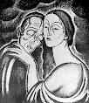
- Henryk Berlewi, Khonon and Lea, image for Dybbuk by An-Ski, 1921, lithography, Jewish Historical Institute, Warsaw http://www.flickr.com/photos/ceno4/4604115983/

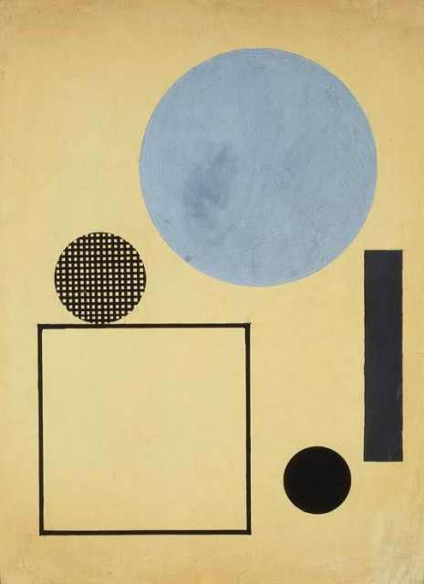
- Henryk Berlewi, Circle and square in the space, (Mechano Facture in Black and Blue), guache, Indian ink, pencil1923, National Museum of Warsaw.
http://malalitera.wordpress.com/2010/07/06/henryk-berlewi
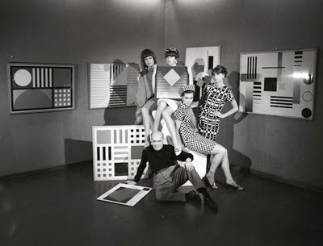
- Photograph by Edward Hartwig showing Henryk Berlewi and his neo-mechano-factures accompanied by Models in Hotel Europe, Warsaw, 1960s, Copyright and Courtesy Gaiser & Cie.
http://henrykberlewiarchive.blogspot.com/2009/11/welcome-to-henryk-berlewi-archive.html

